The intensity of the desert sun penetrates my fur. It feels like it is scorching my skin. It is so hot that the heat rises off the ground in rippling waves. The need for water grows more intense 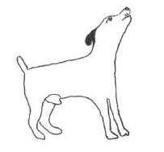every second. I am becoming weak. Using my keen sense of smell, I try once more to search for water. I catch the slight sense of water coming from only a few yards away. I walk slowly towards the smell and find that it is locked inside of a prickly plant. Something tells me to stay away because of the sharp needles, but I can’t help myself. I am just so thirsty!

I lean in to take a bite, but just as my mouth nears the outside of the plant, I feel many pricks going into my head and snout. It feels like I’m being stung by a million bees.
“AWHOOOOOOOO!”, I holler out of pain.
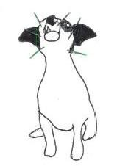

Eventually, the pain in my head begins to ease, but then my stomach rumbles, reminding me how thirsty and hungry I still am. The hot wind brings to my nose the faint scent of people and even better, the scent of food! I smell meat! Grilled meat! A barbeque perhaps? Just the faint smell causes my stomach to growl again.

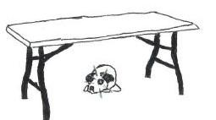
I follow my nose. After a long hot walk, I finally arrive at the location of the smell. My paws ache and I feel extremely weak. I lay down in the only shade I can find under a white table. There are so many strange people here, and they all scare me. But between the frightening rush of feet, I can see a hot dog that has fallen to the ground.

“Now is my chance!”, I think as I scurry between the sea of legs. I finally approach the hot dog and gulp it down in one bite. As I enjoy the juicy taste of my hot dog, I see a jug of water under the table. With my paws I knock it on its side and drink from the spilling stream of cool, fresh water. Suddenly, a loud noise makes me jump. I recognize the noise as music, but it certainly is not any music that I would listen to. This music is accompanied by people dancing and singing along. It is very loud and very scary.
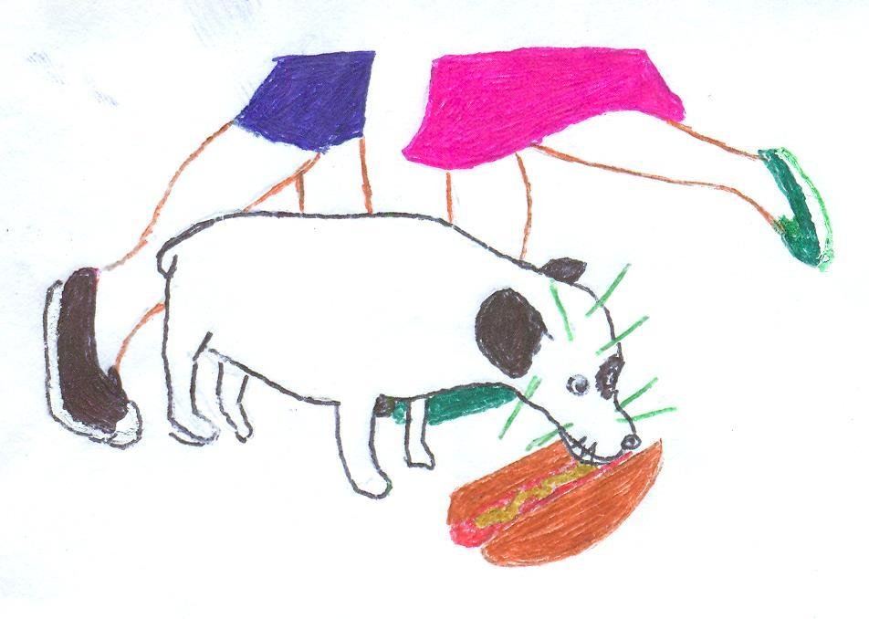

I run at full speed back to my shady space and crawl under the table in an effort to drown out the noise. When I’m tucked far under the table, I realize how sleepy I am, and fall into a slumber almost immediately.
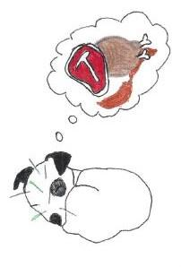
The noise disappears instantly and I find myself in a field of hot dogs and steaks and salami and hamburgers and chicken. It is raining delicious treats and I gorge myself with the bounty of food. But my dream is rudely interrupted when my body begins to shake uncontrollably.
I look up to find a big man with very little fur on his head staring at me. I bark out of surprise and terror.
“Shhh. It’s okay, Puppy.” The man says in a hushed tone to me. I notice it is now dark.
“I am not a puppy.” I growl at the man to show him I can take care of myself. It becomes clear that he does not understand me when he laughs and his big hands reach out and grab me. I find myself letting him pick me up and cuddle me because I am too weak to struggle.
“Oh my goodness!”, he said inspecting me closely. “How did you get cactus thorns in your head? I’ll take you to the shelter. They will fix you up and find your home.”

I don’t understand everything he says, but for some reason, I begin to like this strange furless man. I think it is because he smells like sausages and sweet lemonade. He carries me in his arms and places me carefully in the front seat of his car. He closes the door. It is hot and uncomfortable in here. I start tremble out of fear when the car starts to move. What did the man mean by “shelter”? Where is he taking me? The non-furry man notices my shaking and puts one hand on my back to try to calm me down.
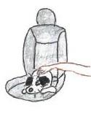

“We’ll be there soon and they will fix you all up, little guy.” I look at him, as he says this, and feel that he truly means it. Wherever I am going, I’m sure it will be a good, happy, food-filled place. With thoughts of this ‘shelter’ swimming in my head, I drift off to sleep. Not long after, I am woken by the non-hairy man’s hands lifting me from the car. He carries me into a strange building.
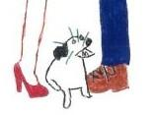
“Hi, there, little guy. Welcome to the Coachella Valley Animal Shelter,” says a woman with bright red shoes. She takes me from the non-hairy man and walks me into a room that is void of any smells.
“We are going to get those nasty cactus needles out of your head, little guy.” The woman proceeds to stick a needle in my thigh and I begin to get very woozy. In a matter of seconds I doze off. Finally, I awake and immediately indulge in the food and refreshing water that has been put in front of me. The woman with the red shoes walks back into the room when I am mid-chew.
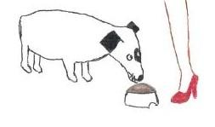

“You look so much better! Here you go, little fellow,” she says as she slips a leash around my head. The woman guides me through a series of doors and into a back room where I can see and hear many different dogs in metal enclosures. Dogs of all shapes, sizes, and colors whine and bark in unison. I am completely overwhelmed by all the dogs trying to speak to me. They are all barking, howling and whining, but I can’t understand any of them because they are all talking at the same time. I try to ignore them and focus on where the red shoe lady is leading me. We walk to the end of the line of dogs, and I see there is an open enclosure. She walks in and coaxes,

“In here, Buddy. Hopefully you’ll get out soon and live with a nice family,” the woman begins. I follow her into the kennel and she takes the rope from around my neck and give me a friendly pat. “Too bad they all want puppies,” the woman says before she walks away. After she leaves the other dogs quiet down and I begin to investigate my new habitat. I have food, water, and a bed. I lie down on my bed and start to wonder, “What does red shoe lady mean when she says families only want puppies?” I fall asleep thinking about happy puppies and women with red shoes.
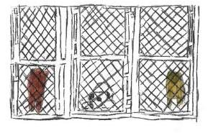
The morning comes quickly and the dogs continue their barking. From my enclosure I can see families with little boys and girls walking into the rooms with all of the puppies. “Why can’t I be a puppy instead of an adult dog?” I wonder. The only person who comes into the dog room is the red shoe lady to give me more food and take dogs away. Some dogs go away for walks and some go away and never come back. I wonder where they’ve gone. Days pass and still no one, but the red shoe lady comes into our area. Still, I can’t really complain. I have a bed to sleep on, food to eat and water to drink. Even so, I can’t help longing for something the other dogs call “a home”.
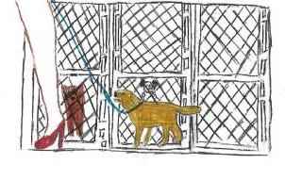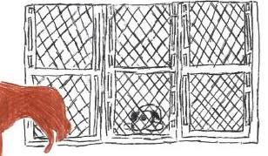
One day a woman with long brown fur not only comes into my area, but she also stops in front of my enclosure.
“You have such a cute little underbite! I don’t see why anyone would pick a puppy over you.” She has a big smile on her face. I jump on the bars. “Hi!”, I bark. “Do you want to play?” She opens the door and slips a leash over my head and onto my neck. She guides me all the way out the front door of the shelter and into a car.
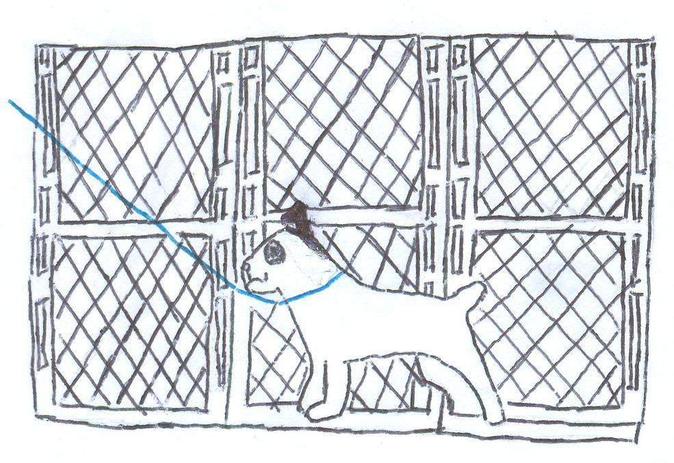

She starts the engine,“Don’t you worry. I am going to take you to a better shelter where there are less puppies.” she says. We ride in silence for a while, but the long brown fur lady keeps looking at me whenever she gets the chance. “My name is Aimee, in case you were wondering. Do you have a name?” She asks me with her eyes on the road. Her question makes me think, do I have a name? But my thoughts come to a stop as Aimee speaks again, this time looking right at me. “I think I will name you Herbie. Do you like that?” I lick my nose in approval. Herbie. What a great name!
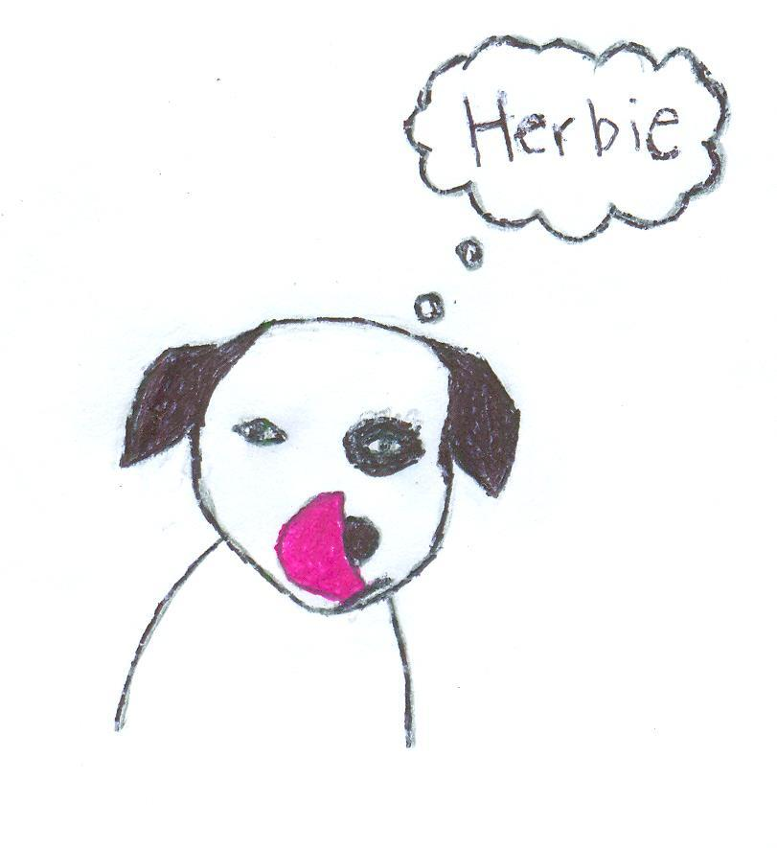
Soon Aimee and I arrive at the new shelter. She slips the leash over my head and walks me inside. I am immediately greeted by many volunteers and brought into a small room. My own room! Although the sudden change in scenery is scary at first, I like this new shelter. My area is much larger and is more clean. I get to take walks every day. And I can always expect to have food, water and a soft bed. Plus, there are not a million other dogs constantly barking at me. There are other dogs here too, but they seem more comfortable and content.

From the window in my room, I can see the humans setting up some sort of gathering. There are tables and food and a big camera. One of the volunteers unlocks my room and slips another leash on me. I bark out of excitement. Maybe I will get to go to this gathering! Maybe there will be hot dogs!
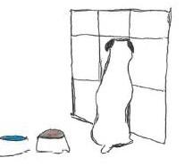

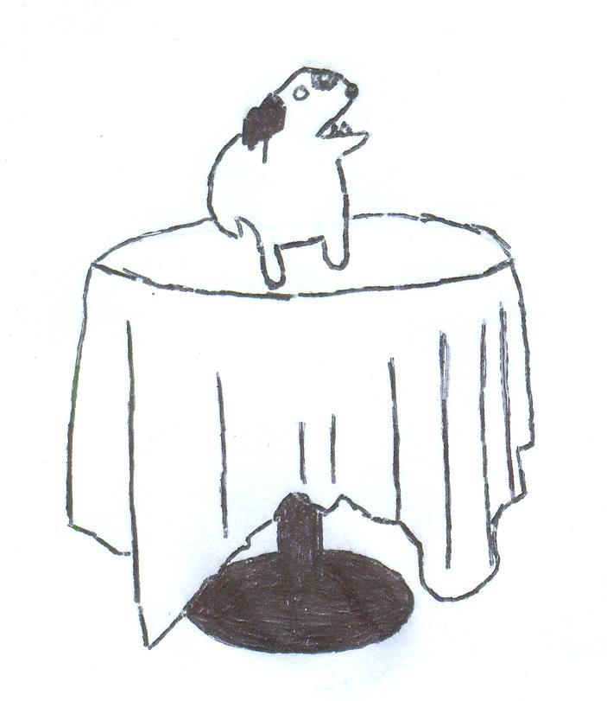“Grab that one and sit him’ up there!” the man behind the camera calls to the human walking me. She scoops me up and sits me on a table. The man presses a button and a red light appears on the camera.
“Welcome back to the San Diego Humane Society Pet Telethon! The next pet up is Herbie. Herbie is a six year old Jack Russell Terrier mix with the cutest little underbite….” I begin to drown out the man’s voice and instead survey the area around me.
After a few minutes he says,“Thank you Herbie. Next dog coming up will be a beautiful poodle named Trixie!” The human guides me off of the table and behind the tan curtain.
The area is warm and sunny and full of dogs and people talking on telephones while sitting on chairs. Chairs! I lie down under a chair to hide from the bright sun. After a couple seconds, I notice a new pair of shoes. I really like these shoes. Something about these shoes feels right. So I sit on them. A face peers at me from above the chair. I look up at the face and a sudden feeling of warmth washes over me.
“Hi there, Herbie!” She exclaims as she picks me up and sits me on her lap. Everything about her is perfect. Her blonde fur, her nice voice. I know right away I am meant to be her dog.
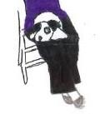

I lick my nose and smile. She laughs and in that moment I know that I have found my perfect home. She leads me to a long table where I sit patiently while she finishes signing some papers and takes me to her car.
“You’re all set, Maureen. Have fun with the newest member of your family!” The smiling woman behind the long table says this to my new owner as she hands her the paperwork.

Maureen walks me to her car and I can’t conceal the skip in my step. We climb into the car and I settle on the passenger seat. She rolls the window down so that we can enjoy the warm breeze together. During the entire ride, Maureen talks excitedly about how much I am going to love her home and all of the things we are going to get to do together; going for walks in the park, sleeping on the edge of her bed, learning new tricks and snacking on yummy treats, and volunteering as an Animal Ambassador for the San Diego Humane Society where I will get to help children and animals learn how to respect and play with one another.

My tail is wagging uncontrollably while Maureen talks of our upcoming adventures, but all I can think about in this moment is how happy I am to finally be going home.
